PROJECT – 3

Elkhan Ismayilzada

**Compression**

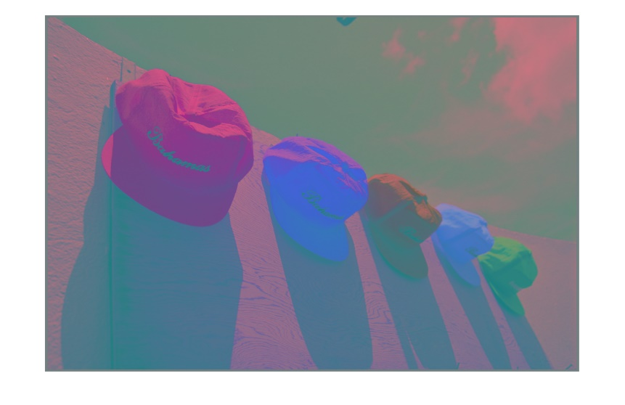

Ycbcr Image is given above. The size of X matrix is found to be 64x98304. The size of C matrix is found to be 64x64.

Size of T matrix is found to be 64x64.

As can be seen from the MSE vs K figure, when we increase the number of principal components, the mean square error between the original and reconstructed image decreases. It is noticeable from reconstructed images as well. If you look at it carefully, you can see that when K=1 the image is in least quality whereas when K = 4, the image is as close as the original image in terms of quality.

**Detection**

The size of L matrix is found to be 10304x20 and size of x is found to be 3x20.

I trained detector for 10 epochs with a learning rate of 0.001 and I got the following results in testing dataset.

As you can see from the results, my detector can perfectly distinguish the male faces from female faces i.e., recall is 100%.

**Restoration**

2D blur kernel is shown below:

When restoring the image from the blurred image, I put a termination condition such that if the change in loss is less than 1 for 3 consecutive times then break the process. I got following MSE results for blurred image without noise and lambda:

As you can see from the graph, ||a||^2 is inverse proportional to ||b-Ha||^2.

I chose lambda based on the best outcome I got from MSE results, and I found it to be 0.01. All the restored images with their corresponding lambdas and MSE results is shown below:

